Designating a student as a "lost child" and withdrawing the student from enrollment with a code 86 should be a process of last resort. Filing an Unable to Locate/Lost Child Report means that the child's whereabouts are unknown to the school, and cannot be determined even after exhausting all possible methods and resources.
The unable to locate/lost child process consists of three steps a school must take:
(1) Attempting to contact the family via all known phone numbers.
(2) Conducting a home visit to the last known address.
(3) Mailing a certified letter with return receipt requested to the last known address.
If an Unable to Locate/Lost Child Report is filed, one copy of the report must be kept in the student’s attendance folder, and one must be sent to the school’s Network office. This includes all ISP, Contract, Charter and Option schools.
Note: All students withdrawn with a code 86 will count toward the school’s dropout rate.
The breakdown below provides more details around the requirements of this process:
STEP 1:
Contact the family via phone, making use of all known phone numbers.
- If the parent/guardian is reached via phone, and:
  - The parent/guardian knows the whereabouts of the student, the child cannot be designated a "lost child".
  - The parent/guardian does not know the whereabouts of the student, and has no means to contact the student, the student can be designated a "lost child" and withdrawn after the school’s receipt of a police Missing Person’s report.
- If all known phone numbers are out of service, incorrect, or go unanswered, and any siblings of the student have been asked for updated contact information, yet the parent/guardian still cannot be contacted via phone, proceed to Step 2.
STEP 2:
Conduct a home visit to the last known address.
- If the parent/guardian is contacted at the home, and:
  - The parent/guardian knows the whereabouts of the student, the child cannot be designated a "lost child".
  - The parent/guardian does not know the whereabouts of the student, and has no means to contact the student, the student can be designated a "lost child" and withdrawn after the school’s receipt of a police Missing Person’s report.
- If the address is incorrect or does not exist, and all other means of contacting the family have failed, the student can be designated a “lost child” and withdrawn with a code 86.
- If the parent/guardian is not contacted at the home, but no clear evidence exists that they no longer reside at the home, proceed to Step 3.
STEP 3:
If all other attempts to contact the family have failed, the school shall mail the parent/guardian a certified letter with return receipt requested to the last known address. The letter should instruct the parent/guardian to immediately contact the school. The 10-day letter serves this purpose as well.
- If the certified letter cannot be delivered and is returned to the school, the student can be designated a "lost child" and withdrawn.
- If the letter is successfully delivered and/or the parent/guardian responds, and:
  - The parent/guardian knows the whereabouts of the student, the child cannot be designated a "lost child".
- The parent/guardian does not know the whereabouts of the student, and has no means to contact the student, the student can be designated a "lost child" and withdrawn after the school’s receipt of a police Missing Person’s report.
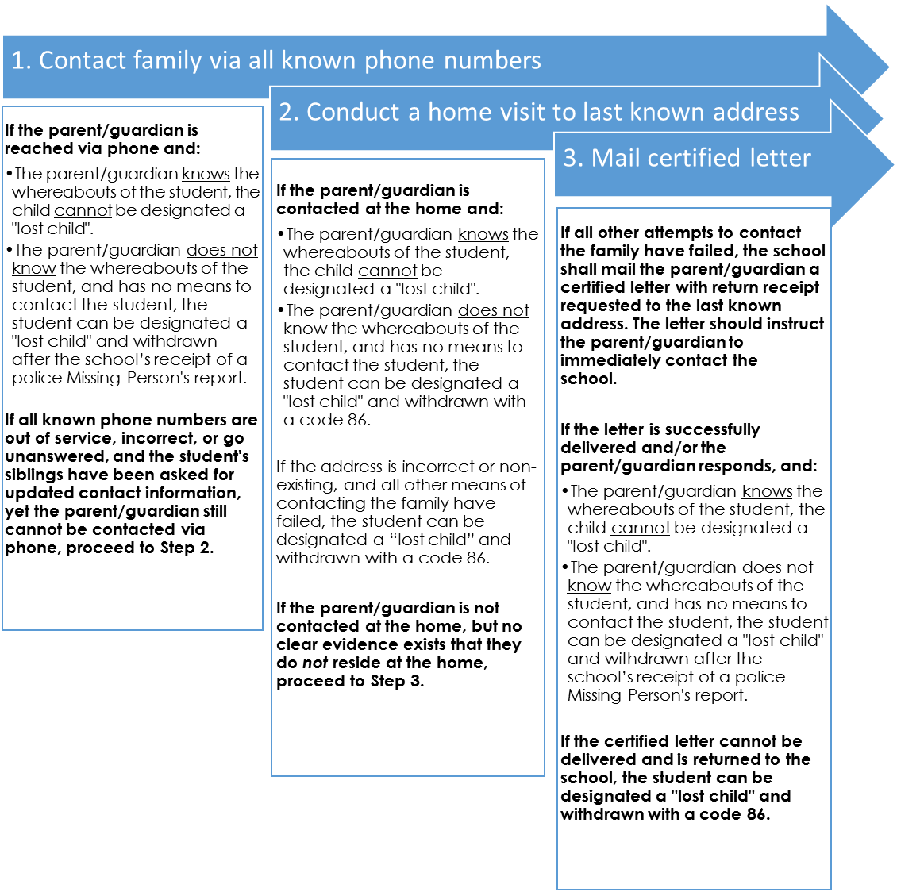

** If a Lost Child Report is filed, one copy of this report must be kept in the student’s attendance folder, and another must be sent to the school’s Network office. **
** The process for sending 5- and 10-Day Truant letters must be followed at all times. **

REQUIRED INFORMATION
SCHOOL INFORMATION
Report Date |  |  | School name
School ID number |  |  | Network
Principal name
Principal phone number |  |  | Principal email
Attendance clerk/ coordinator name
Attendance clerk/ coordinator phone number |  |  | Attendance clerk/ coordinator email
STUDENT INFORMATION
Student name
Student ID number |  |  | Student date of birth
Student age |  |  | Student grade
Parent/Guardian name
Student address
Contact phone numbers
Names and IDs of any siblings enrolled in CPS, and school(s) where they are enrolled
STUDENT DATA
Student’s average daily attendance percent for the current year and past 3 years (if available), at the time the investigation began |  | Total overall absences, total excused absences, and total unexcused absences at the time the investigation began |  |  | Number of days enrolled at the school
SY______: Attendance %  SY______: Attendance %  SY______: Attendance % |  | Overall ______ Excused Absences _______ Unexcused Absences
Last date the student was in attendance
Last date contact was made with the student |  |  | (please type narrative of interaction below)
Description of interaction
Last date contact was made with the family |  |  | (please type narrative of interaction below)
Description of interaction
Free response space for any other relevant notes about this student
REQUIRED DOCUMENTATION
ACTION |  | BY WHOM | DATE | RESULT  (describe the interaction, outcome, and planned next steps)
STEP 1:  Phone calls made to all known contact numbers (including checking with siblings for any other known numbers) | List contact number #1:
List contact number #2
(if applicable):

List contact number #3
(if applicable):

List contact number #4
(if applicable):

STEP 2:  Home visit made to last known address | List address #1:
STEP 2:  Home visit made to last known address | List address #2  (if applicable):
STEP 3:  Certified letter mailed, return receipt requested, to last known address | List address #1:
List address #2
(if applicable:

Student withdrawn from enrollment with a Code 86
(you must attach either a copy of the returned certified letter or a copy of the Missing Person’s Report to this form)

PRINCIPAL CERTIFICATION AND APPROVAL
I certify that this school has completed an investigation to confirm _________________________’s status as a "lost child", prior to removing the student from enrollment with an IMPACT Withdrawal Code of 86.

Signature must be provided by hand; an electronic signature will not be accepted.

PRINCIPAL – PRINTED NAME | PRINCIPAL – SIGNATURE

SECOND STAFF MEMBER – PRINTED NAME | SECOND STAFF MEMBER – SIGNATURE

The original copy of this report, as well as the returned letter or Missing Person’s report, must be filed in the student’s Attendance Folder. Send a second copy to the school’s Network office.

